BASEBALL UMPIRES MECHANICS
Four-man Mechanics
審判メカニクス（４人制）

Basic signals and calls, General knowledge,
Official Rules, Mechanics
基本動作・一般心得と責任・公認規則・メカニクス

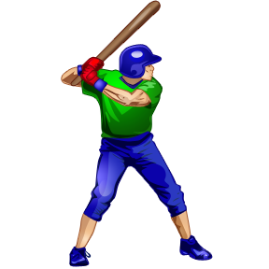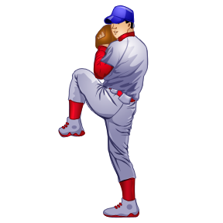

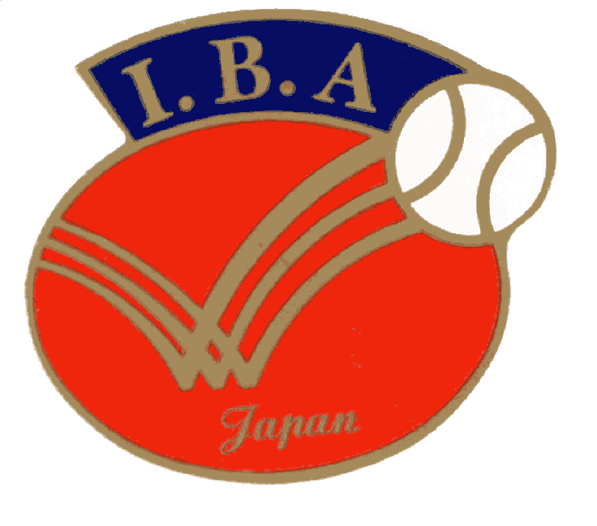
IBA-boys
International Boys Nankyu Baseball Association, Japan
2016

